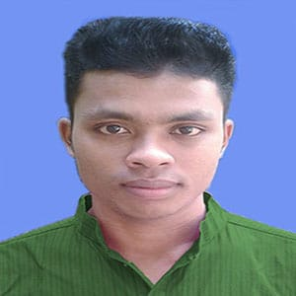
MD. MAHABUR ISLAM
Address :
Village : Paschim Kanthali-1
Thana : Jaldhaka, Dist. Nilphamari
Mobile No : +8801733247923
- mail : mahaburbrur@gmail.com

CAREER OBJECTIVES

To obtain a position with opportunities to utilize my technical knowledge and marketin experience, skill, talant, creativity, sincerity for the better achievement of the organization.

EDUCATIONAL BACGROUND
BA in BANGLA
Institution : Begum Rokeya University ,Rangpure
Academic Result : CGPA 3.50 (Out of 4.00)
Passing Year : 2026
Course Duration : 4 Years

Higher Secondary Certificate (H.S.C)
Institution : Jaldhaka govt. Collage
Academic Result : GPA 4.17 (Out of 5.00)
Passing Year : 2020
Group : Humanitise
Board : Dinajpure

Secondary School Certificate (S.S.C)
Institution : Kanthali Shedul Caust High School
Academic Result : GPA 4.33 (Out of 5.00)
Passing Year : 2018
Group : Science
Board : Dinajpure

LANGUAGE PROFICIENCY
Language | Reading | Writing | Speaking
Bangla | good | good | good
English | good | good | good

MY TRAITS
Good time management
Good comminication Skills
Self motivated
Efective dicepline skills
Ability to take challenge

INTERESTED AND HOBIES
Reading & writing
Traveling
Social working
Sports
Personal Details
Fathers name | : | Asinur islam
Mothers name | : | Marufa Begum
Date of Birth | : | 12 january 2001
Gender | : | Male
Marital status | : | Unmarried
Nationality | : | Bangladeshi
National id No | : | 35467893290
Religion | : | Islam
Permanent add | : | Vill. Santibag; Tajhat,Rangpure
Declartion :
I solemnly declare that all information provided here is accurate and true to my knowledge.



signatur

